PROJECT TITLE

GARAGE MANAGEMENT SYSTEM

**College Name: AVP COLLEGE OF ARTS AND SCIENCE**

**College Code: AJ**

**TEAM ID: NM2025TMID25299**

**TEAM MEMBERS: 4**

**Team Leader Name: SRI SELVA NAYAGI. S Email:sriselvanayagi1031@gmail.com**

**TeamMember1: ASWITHA. F**

**Email: thaaswi118@gmail.com**

**Team Member2: JESILA PARVEEN. M**

**Email: jannathulfirthous2212@gmail.com**

**Team Member3: NIRANJANA. M**

**Email:**

# INTRODUCTION

## Project Overview

The Garage Management System is a Salesforce-based application designed streamline

And software designed to streamline automate the operations of automative repair and maintained business.

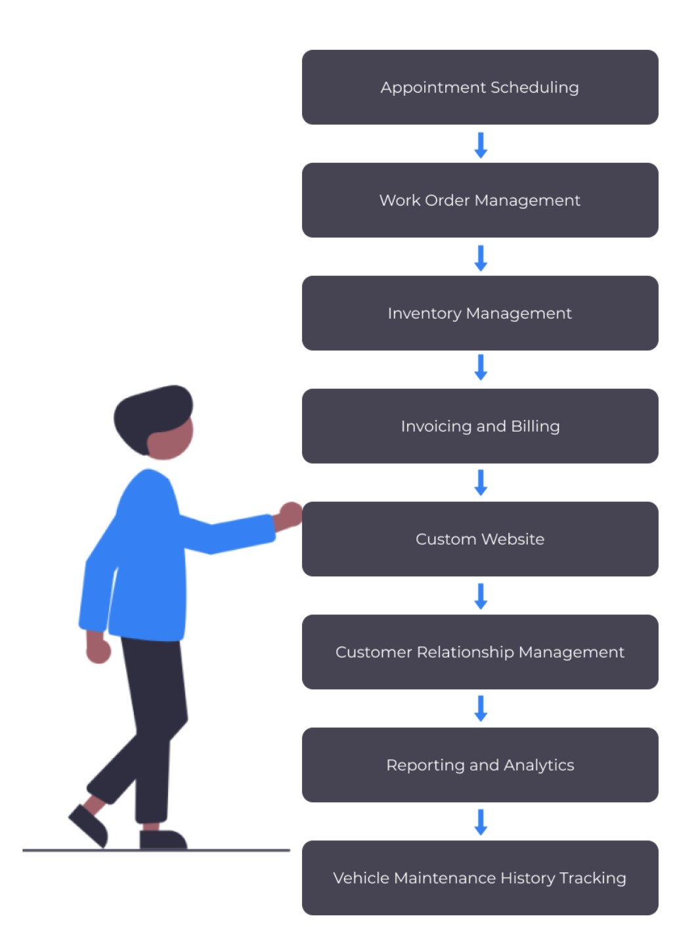

## Purpose

The main objective of the project is to enable organizations to efficiently manage properties, tenants, and lease-related activities. It reduces manual intervention, improves accuracy, and ensures better compliance and communication.

# DEVELOPMENT PHASE

### Creating Developer Account:

By using this URL **-** [**https://www.salesforce.com/form/developer-signup/?d=pb**](https://www.salesforce.com/form/developer-signup/?d=pb)

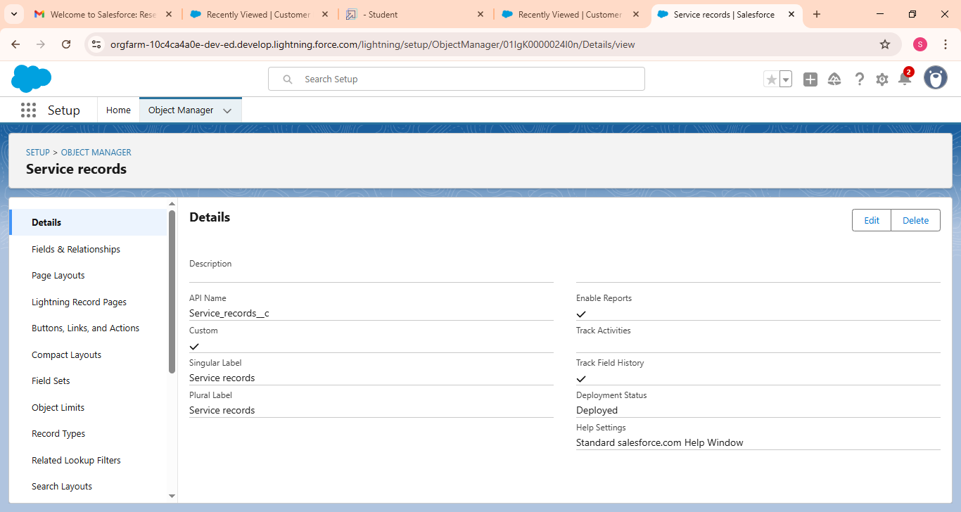

* Service record details

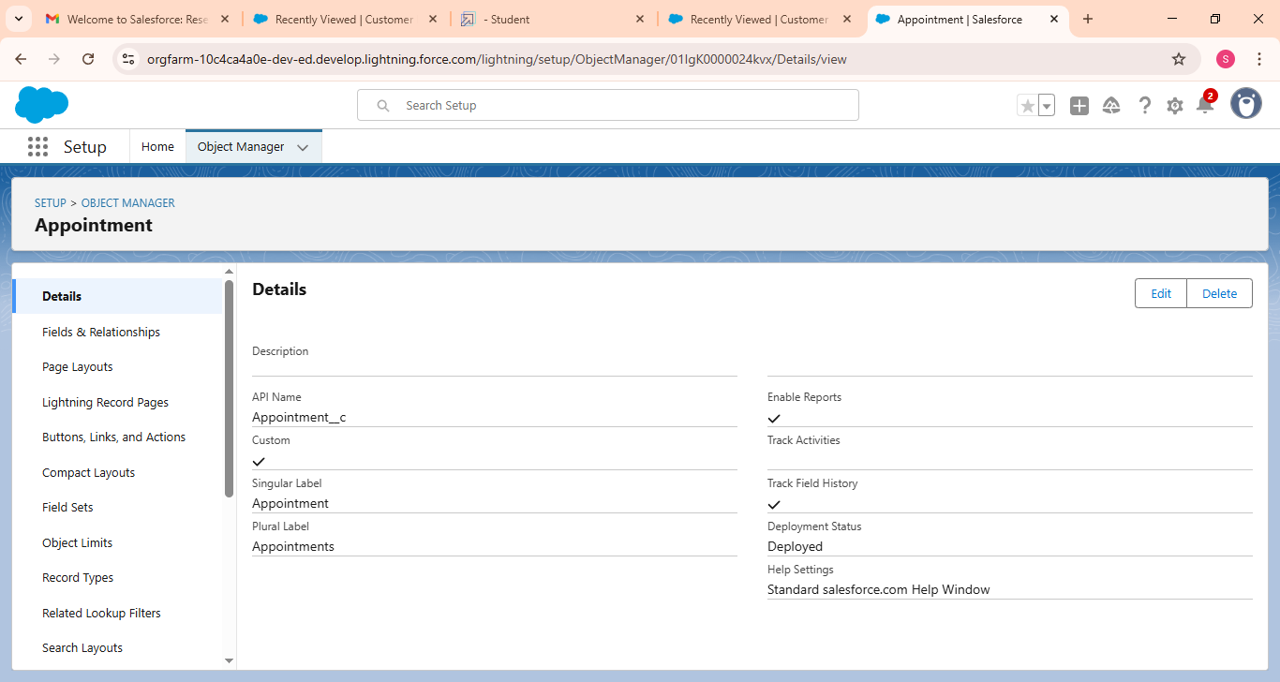

* Appointment details

* Customer details

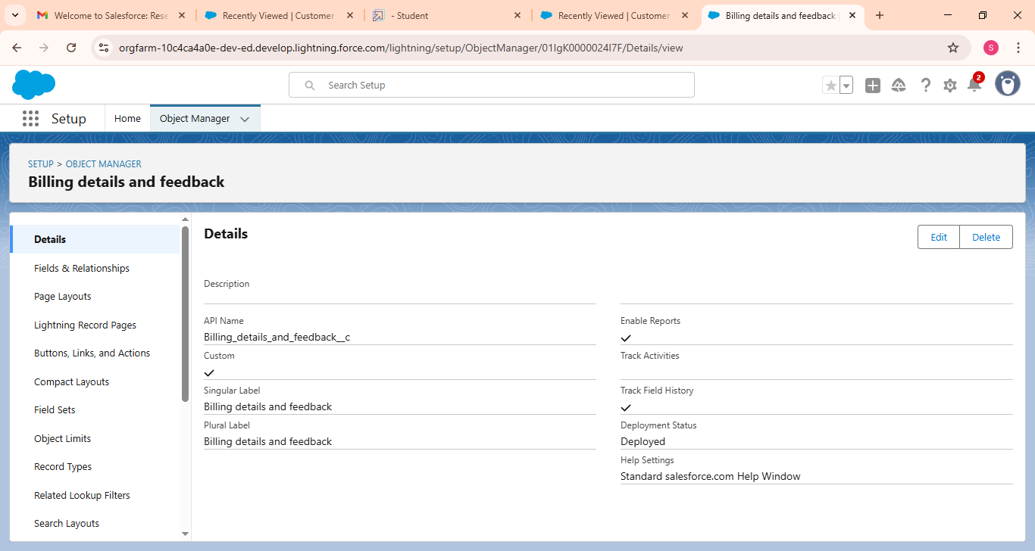

* Created the record of billing

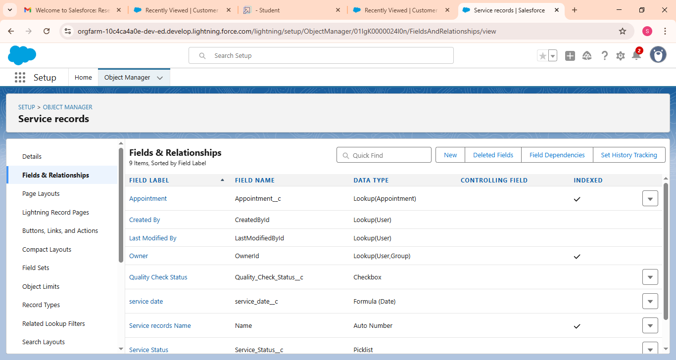

* Created fields and relationship



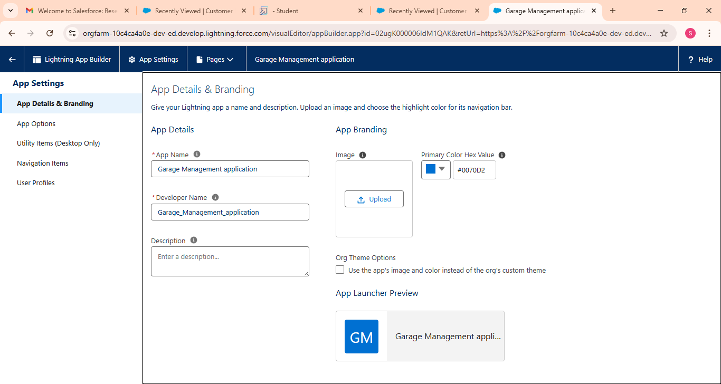

* Developed lighting app with relevant tools

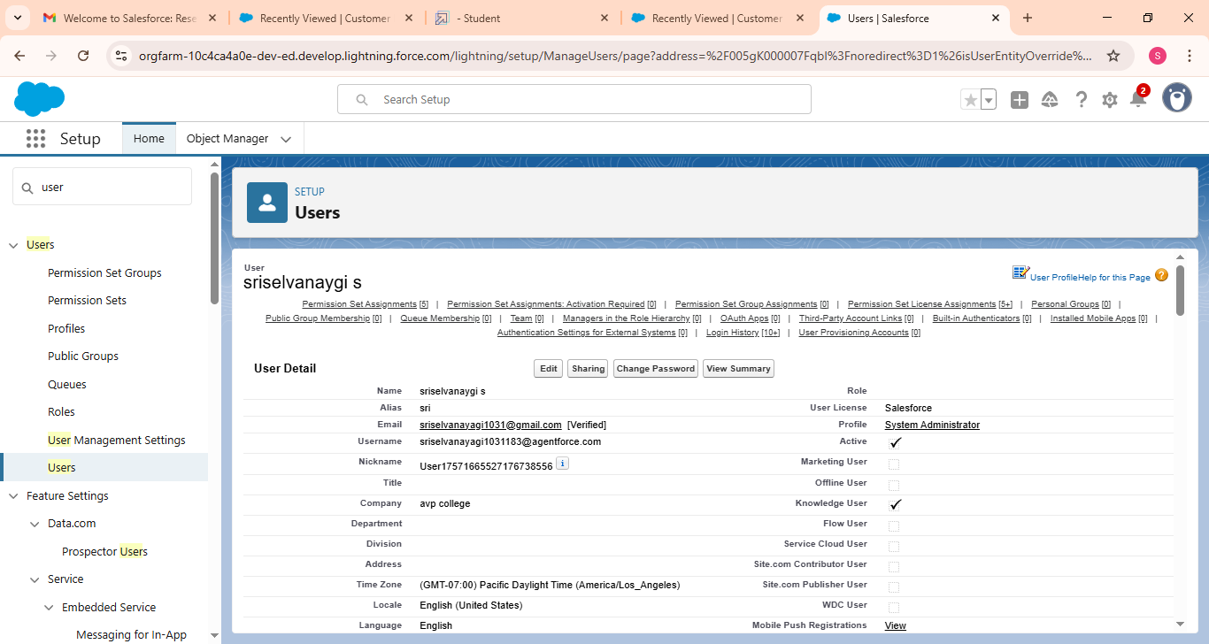

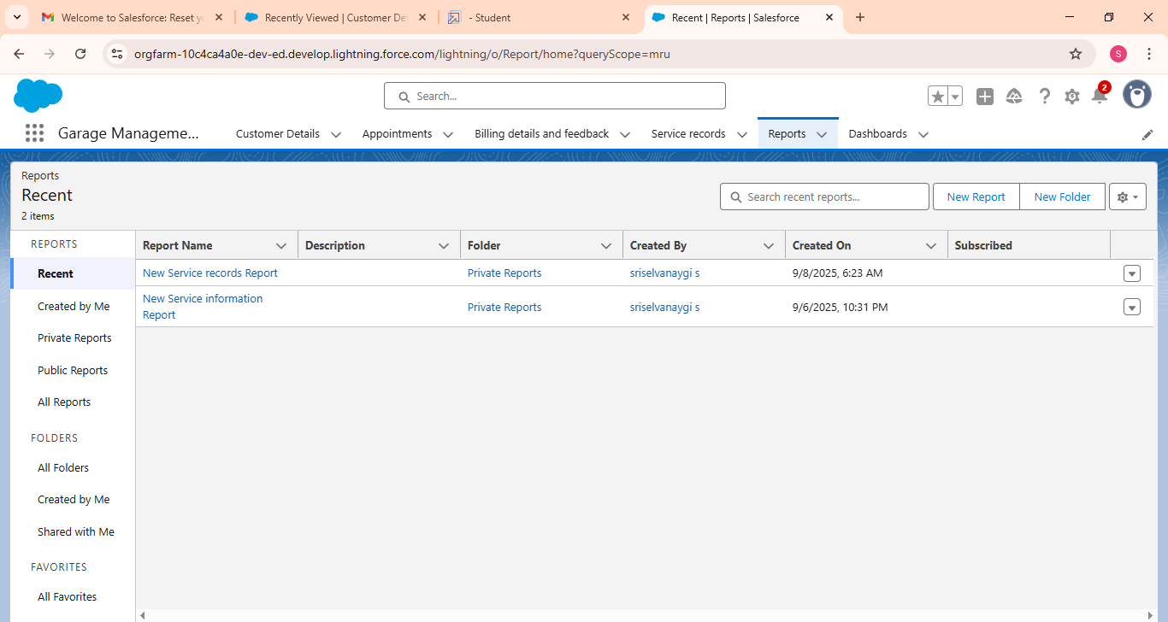

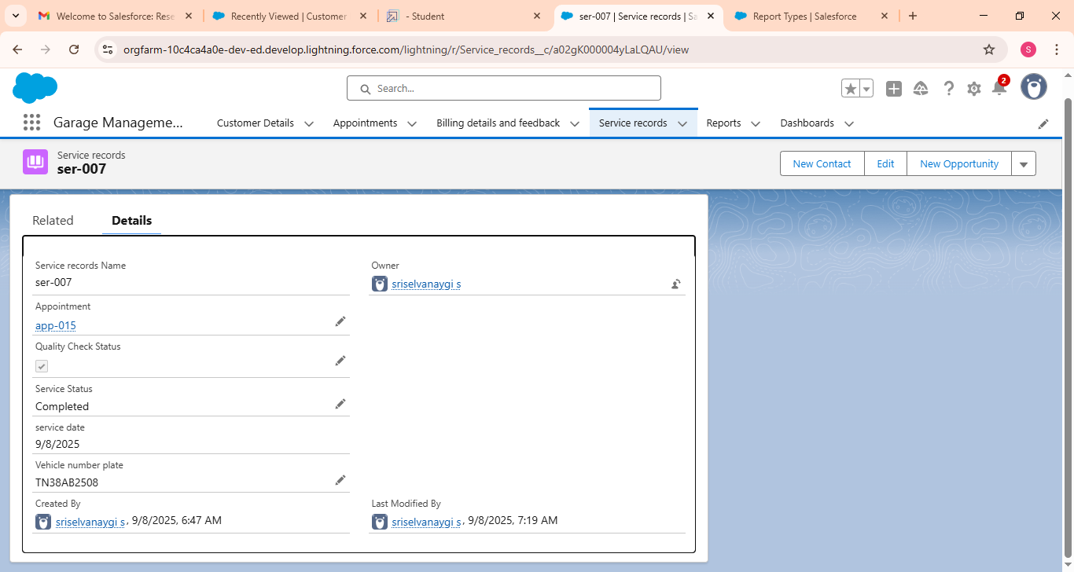

* Appointments created successfully

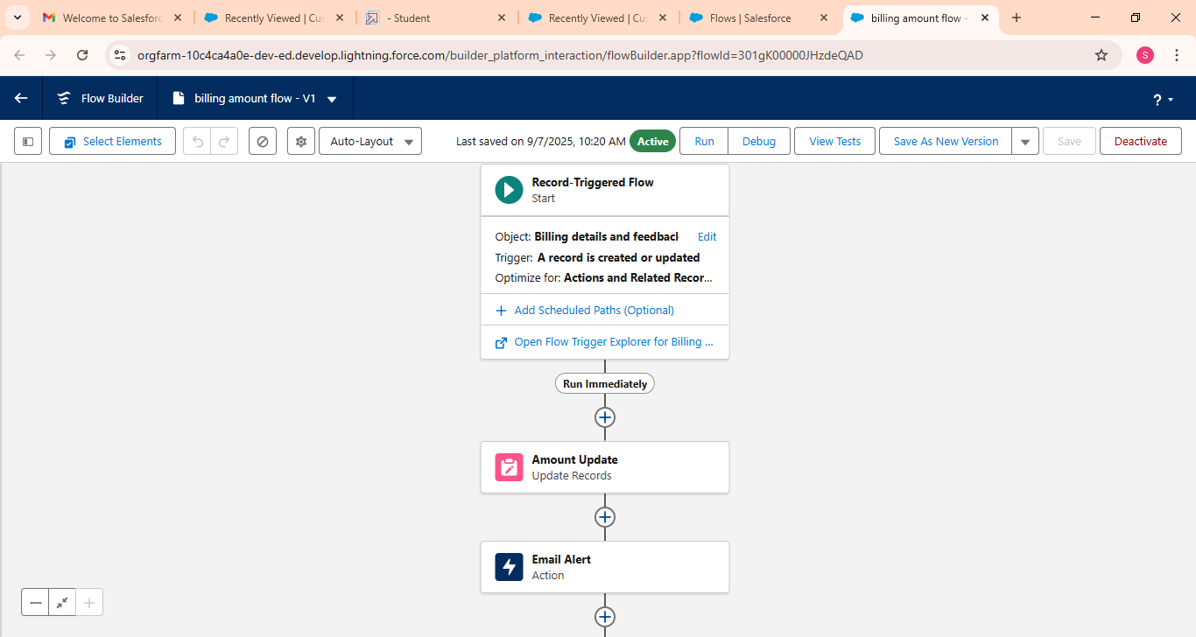



* To create validation rule to garage management

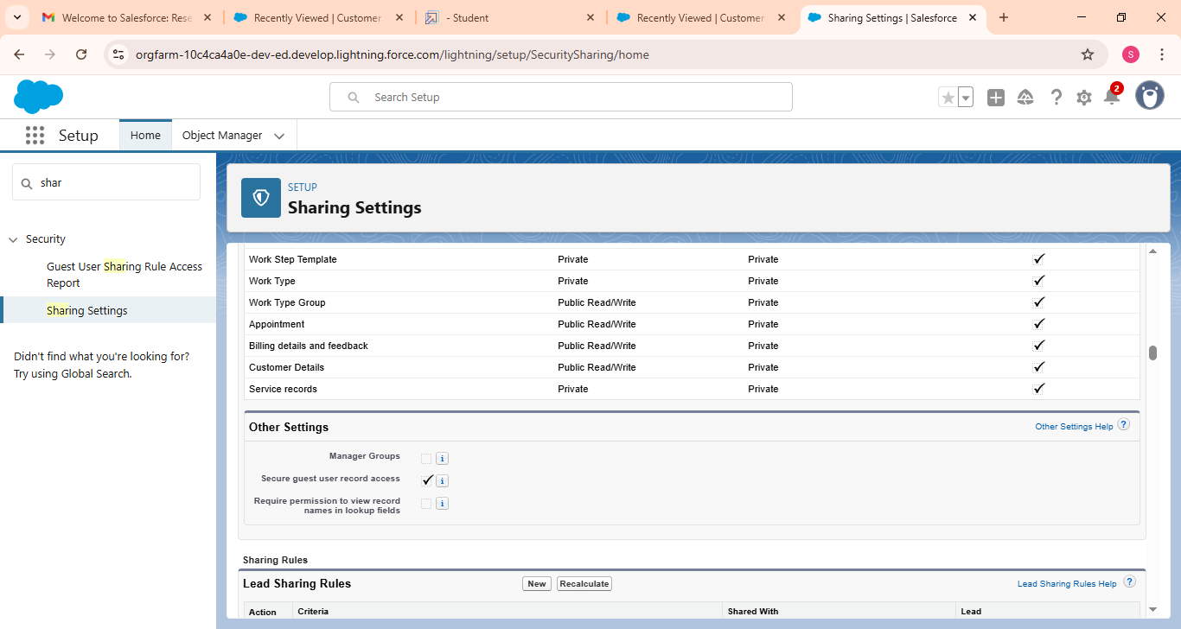

* New service record was created

# FUNCTIONAL AND PERFORMANCE TESTING

## Performance Testing

## 

* Trigger validation by entering duplicate tenant-property records

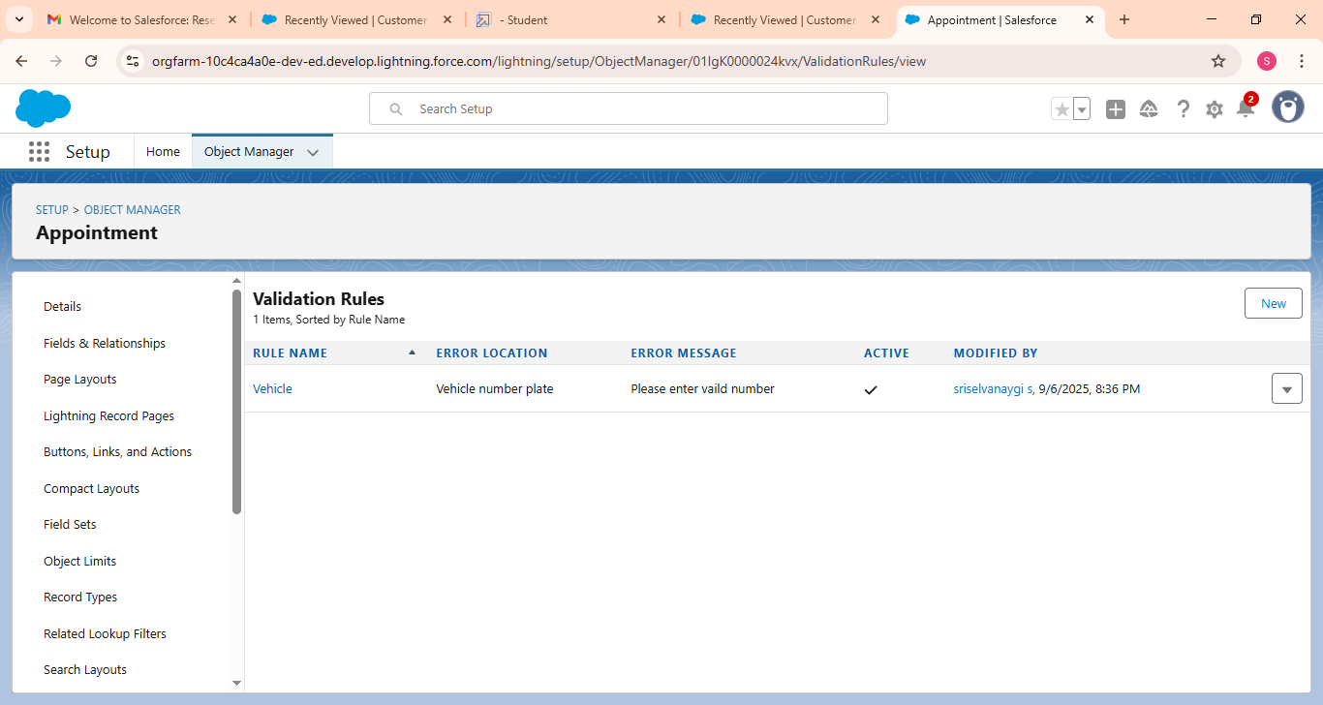

* Validation rule checking

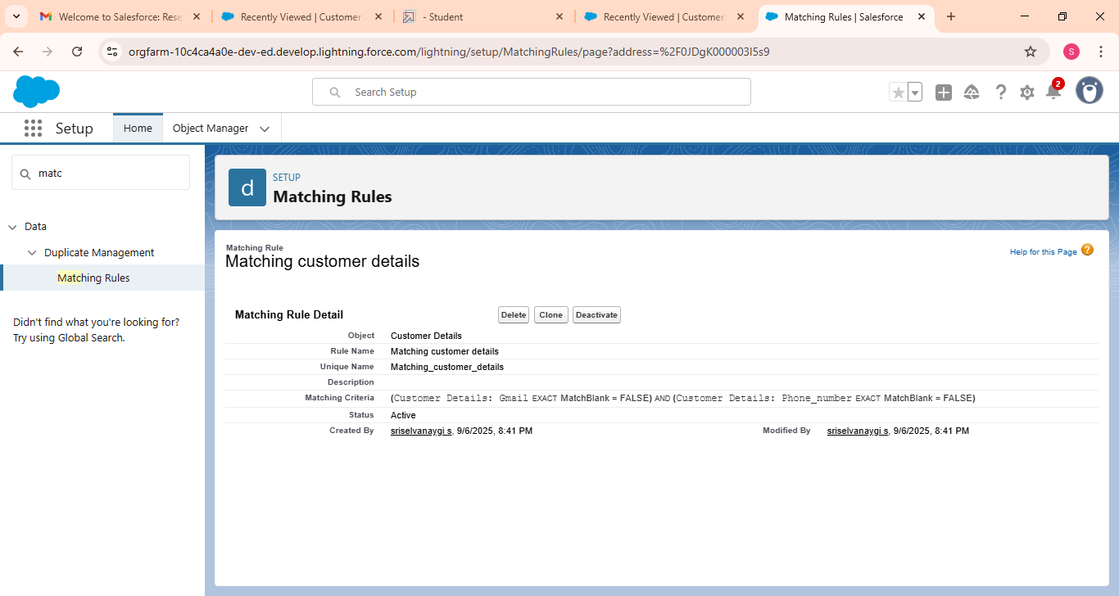

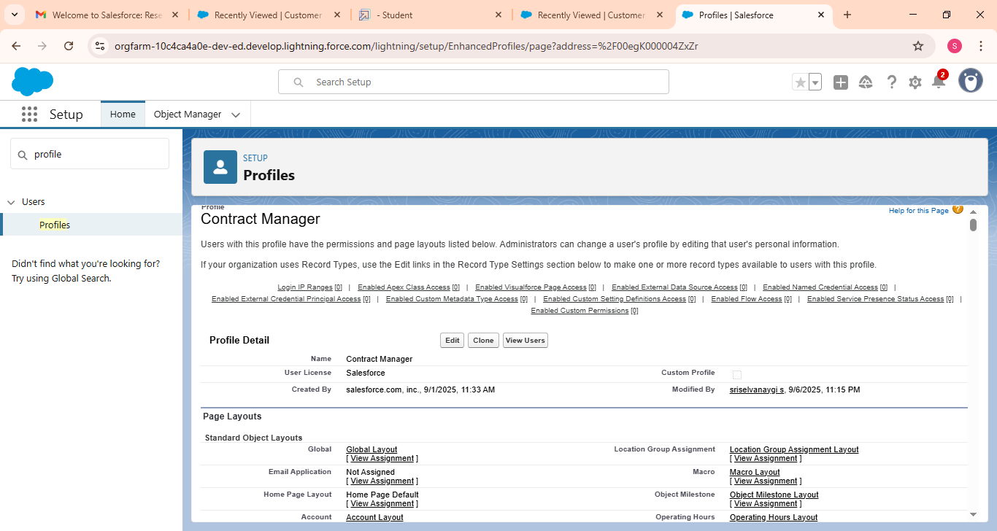

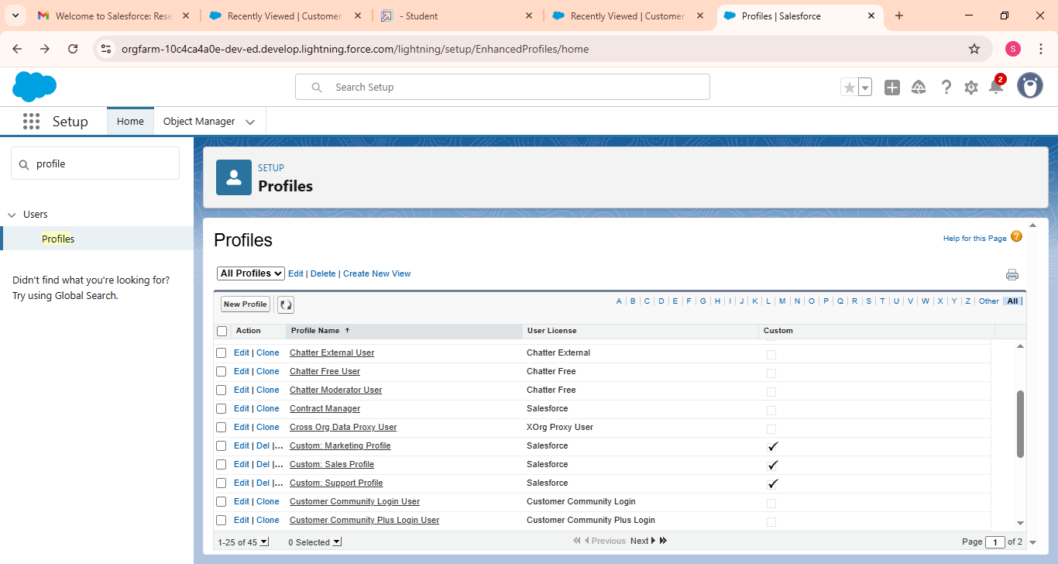

# RESULTS

## Output Screenshots

# ADVANTAGES & DISADVANTAGES.

**ADVANTAGES**

**Increased Efficiency:**

GMS automates routine tasks like appointment scheduling, invoicing, and data entry, reducing manual work and increasing overall garage productivity.

• • **Improved Customer Experience:**

Features like online booking, automated service reminders, and digital job reports improve communication and transparency, leading to greater customer satisfaction and loyalty.

• • **Centralized Data Management:**

All vehicle, customer, and service history data is stored in a single, accessible location, allowing for quicker retrieval and better record-keeping.

**Better Inventory Management:**

Track parts and supplies, get low-stock alerts, and simplify ordering, ensuring you have the right parts on hand and preventing delays.

• • **Enhanced Financial Management:**

Automated invoicing and streamlined billing processes improve accuracy and save time on administrative tasks.

• • **Informed Decision-Making:**

Gain access to reports and analytics, providing insights into business performance to help make more strategic and data-driven decisions

**DISADVANTAGES**

**Initial Cost:**

**The initial purchase and implementation of a GMS can be a significant financial investment.**

**• • Staff Training Requirements:**

**Employees need to learn how to use the new software, which may lead to an initial drop in productivity during the learning phase.**

**• • Internet Dependency:**

**For cloud-based GMS, a stable and reliable internet connection is crucial for accessing the system and its features.**

**• • System Limitations:**

**GMS software is optimized for garage environments and may require significant customization or may not be suitable for other types of businesses.**

**• • Potential Data Security Risks:**

**Storing data digitally, especially in the cloud, can introduce security vulnerabilities if not properly managed.**

# CONCLUSION

The Garage Management System highlight its role as a trans formative tool significantly boosts efficiency, cuts costs and enhances customer satisfaction in automative business by automating tasks like scheduling and billing, centralizing data, improving inventory management, and providing better financial oversight and transparency for future growth.

## APPENDIX

public class AmountDistributionHandler {

    public static void amountDist(list<Appointment__c> listApp){

        list<Service_records__c> serList = new list <Service_records__c>();

        for(Appointment__c app : listApp){

            if(app.Maintenance_service__c == true && app.Repairs__c == true && app.Replacement_Parts__c == true){

                app.Service_Amount__c = 10000;

            }

            else if(app.Maintenance_service__c == true && app.Repairs__c == true){

                app.Service_Amount__c = 5000;

            }

            else if(app.Maintenance_service__c == true && app.Replacement_Parts__c == true){

                app.Service_Amount__c = 8000;

            }

            else if(app.Repairs__c == true && app.Replacement_Parts__c == true){

                app.Service_Amount__c = 7000;

            }

            else if(app.Maintenance_service__c == true){

                app.Service_Amount__c = 2000;

            }

            else if(app.Repairs__c == true){

                app.Service_Amount__c = 3000;

            }

            else if(app.Replacement_Parts__c == true){

                app.Service_Amount__c = 5000;

            }

    }

    }

}

|  |  |
| --- | --- |
|  |  |